ANSWERBOT
AI-Powered FAQ and Customer Support Automation
MAIN PROJECT DOCUMENT
A centralized, secure API platform for FAQ management, authentication, AI-assisted content generation, and semantic FAQ search.
Project Title | AnswerBot – AI-powered FAQ and customer support automation
Technology | Node.js, Express.js, MongoDB, Mongoose, JW bcrypt, Google Gemini AI
Document Type | Main Project Documentation
Version | Final / Editable Documentation

Presented by
Sarmila S(TL)
Janani K
Shalini S
Keerthilakshmi T

PROJECT DOCUMENTATION DETAILS
This document is prepared using the supplied AnswerBot project reference document. It presents the project description, requirements, architecture, database design, API modules, execution procedure, and screenshot placeholders.
The screenshot areas in this document are intentionally left editable so that project execution screenshotscan be inserted later.

SCREENSHOT INSERTION GUIDE
Click inside an 'INSERT SCREENSHOT HERE' box.
Use Word: Insert → Pictures→ ThisDevice.
Select the required screenshot from your computer.
Resize the picture to fit the section and keep the caption below it.
Use screenshots from VS Code, MongoDB, Postman/ThunderClient, browser/API responses, and project execution where applicable.

TABLE OF CONTENTS
- Abstract / Project Description
- Scenario-Based Case Study
- ProblemStatement
- Proposed Solution
- Usage
- Outcome
- Software Requirements
- Hardware Requirements
- Project Architecture
- SystemComponents
- Entity-Relationship Design
- Key Structural Mappings
- Key Features
- Rolesand Responsibilities
- User Flow
- MVCArchitecture Pattern
- Project Setup and Configuration
- Backend Development
- Database Configuration
- API Router Interface Endpoints
- Project Execution
- API Testing Specification
- Screenshots/ Evidence
- Conclusion
- Future Enhancement

ABSTRACT / PROJECT DESCRIPTION
AnswerBot is an AI-powered FAQ and customer support automation platform designed to streamline FAQ creation, user authentication, and AI-powered content management. The backend is implemented as a REST API using Node.js and Express.js, with MongoDB as the primary data store and Mongoose ODMfor data modeling and schema validation.
Security is implemented using JWT (JSON Web Tokens) for stateless user sessions and route guarding, while bcrypt is used for password hashing. The backend also supports automated FAQ generation, semantic search queries, dynamic context parsing, centralized error handling, and response statussanitization.
INSERT SCREENSHOT HERE Project Home / Main Application Screen
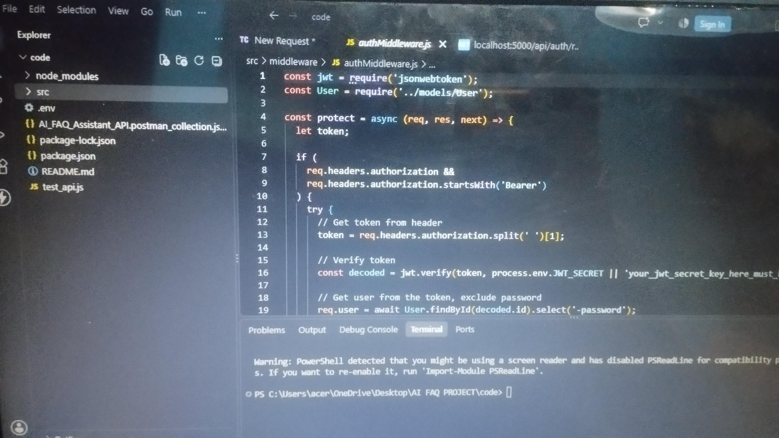
Figure 1: Main project screen / application interface

SCENARIO-BASED CASE STUDY

Background
Priya is a customer support operations manager who handles large backlogs of repetitive user inquiries. She faces difficulties in organizing entries, classifying topics, preparing precise summaries, and tracking client question trendsefficiently.

Problem
Difficulty generating and maintaining up-to-date documentation workflows.
Limited visibility into semantic search match keywordsand rapid query resolutions.
Time-consuming manual processesfor drafting complex support answers.
Lack of unified database permission layersprotecting private documentation from public adjustments.

Solution
The AnswerBot backend provides a centralized and secure API wrapper that separates application business logic from frontend delivery systems. It uses internal verification and service modules for content creation, category keywords, database persistence, and automated text inference.

Usage
Authenticated Creator Usage: registers profiles, requests AI assistance, drafts FAQ schemas, and updatesor removesself-authored records.
Public/Consumer Usage: queries general list routes to consume published articles and performs localized semantic queriesusing parameters.

Outcome
The backend workflow reduces operational delays, maintains data structural integrity through schema validation, uses security tokens to restrict modification to original authors, and supports high-performance data discoverability.

SOFTWARE REQUIREMENTS
Requirement | Purpose
Operating System | Windows10/ 11, macOS, or Linux
Node.js | Version 18 or above
npm | Version 9 or above
Express.js | Version 4/5 ecosystem
MongoDB / Mongoose ODM | NoSQL document storage and data modeling
Postman / ThunderClient | API verification and testing
CodeEditor | Visual Studio Code or similar IDE

HARDWARE REQUIREMENTS
Processor: Intel Core i5 (8th Gen or above) / AMD Ryzen 5 or equivalent.
RAM: 8 GB minimum; 16 GB recommended for concurrent MongoDB processing layers.
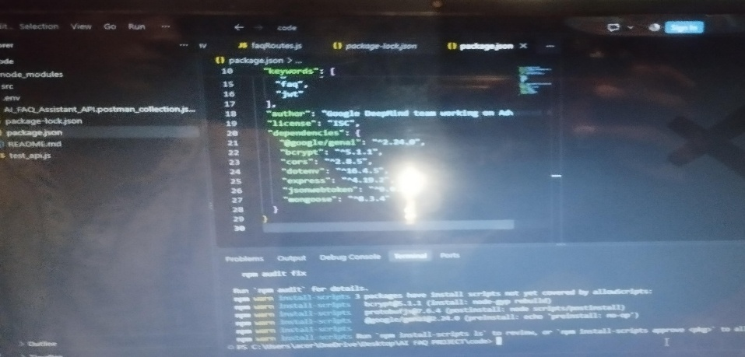
Storage: 1 GB of available disk workspace.
INSERT SCREENSHOT HERE .js / npm Installation
Figure 2: Node.jsand npm environment verification

PROJECT ARCHITECTURE
The AnswerBot application exposes structured endpoints through a layered server architecture. Incoming requestsundergo filter processing before interacting with data services.

Architecture Components
Component | Definition
Interface | API tools such as Postman query distinct route pathsto extract JSON entities.
ExpressServer Gateway | Monitors network ports, maps GET, POST, PUT, and DELETE methods, parses JSON payloads, and handlesCORSheaders.
Authentication Middleware | Extracts authorization tokens, validates user context signatures, and evaluates authorization thresholds for guarded resourcepaths.
Granular Services | Enforces isolated domain rules for user session life cycles and operational query modifications.
Database Interface Layer | Mongoose translates application logic into native MongoDBqueries.
AI Flow | Google Gemini SDK integrations allow the controller layer to perform questionanswering and automated topic generation workflows.
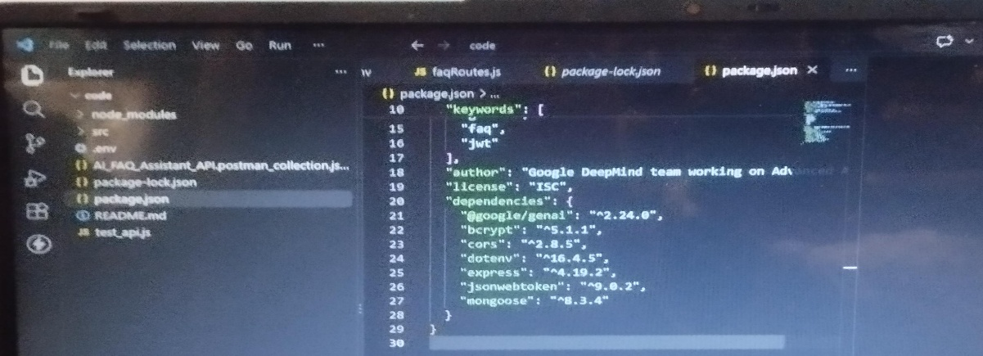
INSERT SCREENSHOT HERE Project Architecture / Folder Structure
Figure 3: Project architecture or VSCode folder structure

ENTITY-RELATIONSHIPDESIGN
The backend database uses multiple MongoDB collections connected through logical references for user authentication, FAQ management, AI-generated content, and category organization.

User Entity
_id –Primary Key (ObjectId) name –String, Required email –String, Required, Unique password –String, Hashed, Required role –String, Default: user
createdAt updatedAt

FAQEntity
_id –Primary Key (ObjectId) question –String, Required answer –String, Required category –String, Required
createdBy –Foreign Key referencing User Collection createdAt updatedAt
AI Generation Entity (Logical) topic–String generatedQuestion –String generatedAnswer –String generatedCategory –String generatedAt
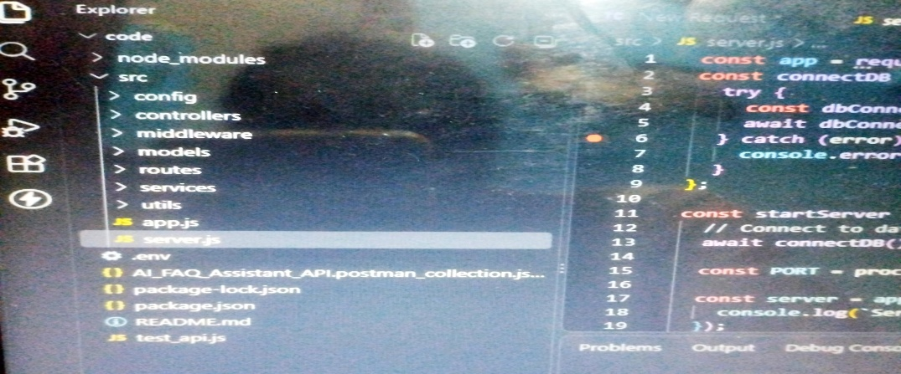
Category Entity (Logical) categoryName –String description –String totalFAQs–Number
INSERT SCREENSHOT HERE ER Diagram
Figure 4: Entity-Relationship diagram

KEY STRUCTURAL MAPPINGS
User → FAQ (One-to-Many): A registered user can create and manage multiple FAQ records.
Category → FAQ (One-to-Many): Each category can contain multiple FAQ documents.
User → AI Generated FAQ (One-to-Many): A user can generate multiple AI-assisted FAQs, which may later be saved into the FAQ collection.
FAQ → Search Results (Logical Relationship): Search queries retrieve matching FAQ documents using keyword and semantic matching.

KEY FEATURES
JWT Authentication & Authorization
AI FAQ Generation using Google Gemini AI
Semantic FAQSearch
Complete CRUDOperations
Category Management
Password Encryption using bcrypt
Centralized Error Handling
Mongoose Schema Validation
RESTful API Architecture
MongoDB Integration using Mongoose ODM

ROLESAND RESPONSIBILITIES

Admin
Manage all registered users.
View, update, and delete any FAQ.
Monitor AI-generated content.
Manage FAQcategories.
Accesscomplete system functionality.

Content Creator
Createnew FAQs.
Edit personal FAQ records.
Deleteowned FAQs.
Generate FAQsusing AI.
Organize FAQsunder categories.
Authenticated User View public FAQs.
Search FAQsusing keywords.
Generate AI-assisted answers.
Accesspersonal profile information.
PublicUser View published FAQs.
Search FAQs.
Cannot create, edit, or delete FAQ records.
No accessto protected API endpoints.
INSERT SCREENSHOT HERE
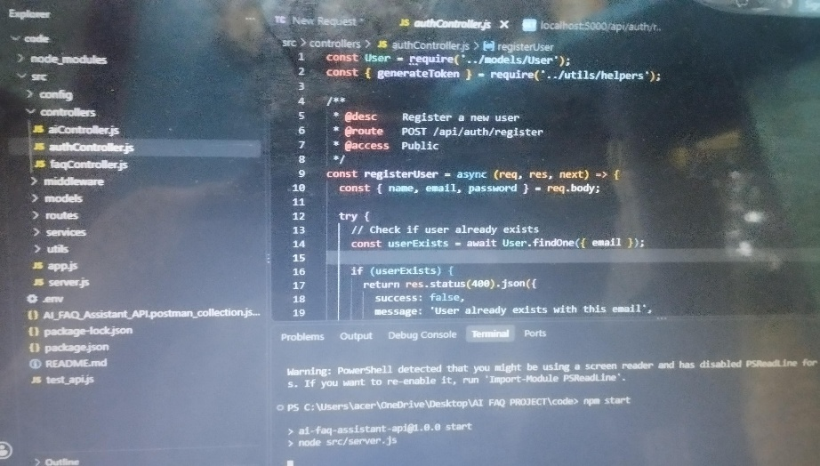
Login / Authentication Screen
Figure 5: User authentication screen

USER FLOW
- User accessesthe API/ application.
- User registersor logsin through the public authentication operations.
- The system validatescredentialsand generatesa JWT token for authenticated access.
- Authenticated userscan create, read, update, or delete permitted FAQ records.
- Userscan search FAQ content using keywords.
- Authorized userscan request AI-assisted FAQ generation.
- The generated content can be reviewed and persisted asFAQ data.
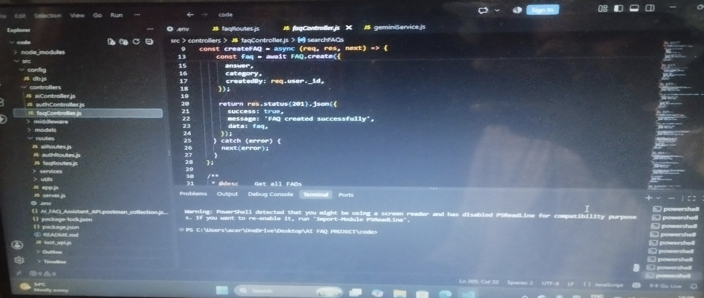
- Public userscan accesspublished FAQ information and search routes.
INSERT SCREENSHOT HERE User Flow / Login-to-FAQ Process
Figure 6: User flow evidence

MVC ARCHITECTURE PATTERN

Model Layer –Data Blueprint
Defines structural blueprints using Mongoose schemas and maps explicit fields into MongoDB collection items. It establishesfield rulesand defaultsbefore validation and persistence.

Controller Layer –Execution Matrix
Acts as the intermediary layer. It captures requests from routes, checks request constraints, delegatesprocessing to modelsor services, and packagesresultsinto standard JSON responses.

View Layer –Routing Network Interface
Because the project is a headless backend service, traditional user-interface templates do not exist. The interface layer is represented by the API routing layer, which maps network requests to controller logic.
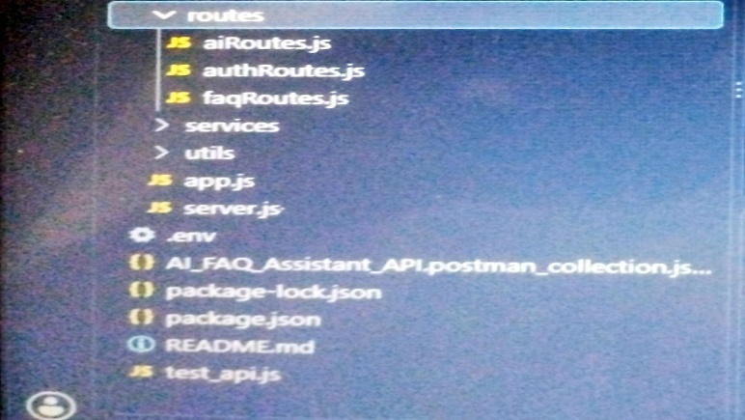
INSERT SCREENSHOT HERE MVC / Route-Controller-Model Evidence
Figure 7: MVC-related source code structure

PROJECT SETUP AND CONFIGURATION

Creating Project Folder
- Create a new folder with the project name.
- Inside the folder, create a subfolder named src.
- Open the project folder in Visual Studio Code.

Server Setup
Open the root folder terminal in VSCode and initialize the Node.jsproject with npm.
Required dependency categories from the reference include Express, Mongoose, dotenv, CORS, JSON Web Token, bcrypt, and the Google Generative AI package.
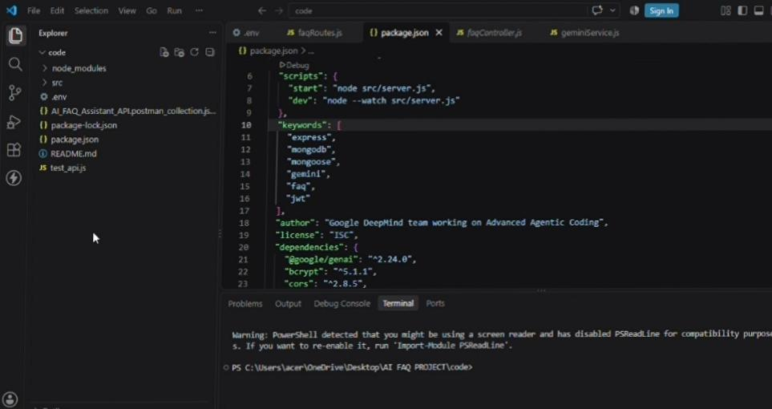
INSERT SCREENSHOT HERE VS Code Project Folder and Terminal
Figure 8: Project folder and npm setup

BACKENDDEVELOPMENT

Gateway Server –src/ server.js
The main entrance mechanism aggregates environment variables, triggers database listeners, and bindsthe application to the active environment port.
INSERT SCREENSHOT HERE src/server.js
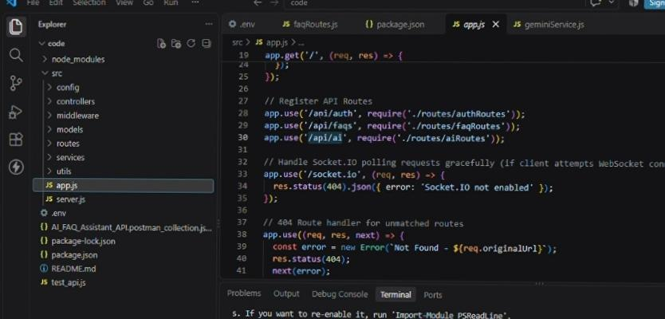
Figure 9: server.jssource code

Gateway ExpressSetup –src/ app.js
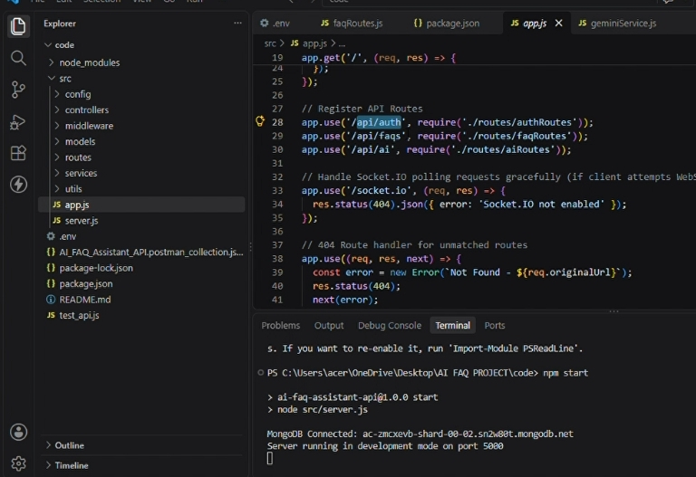
The Expressapplication configuresthe server-side routing and request handling layer.
INSERT SCREENSHOT HERE src/app.js
Figure 10: app.jssource code

Security AccessMiddleware
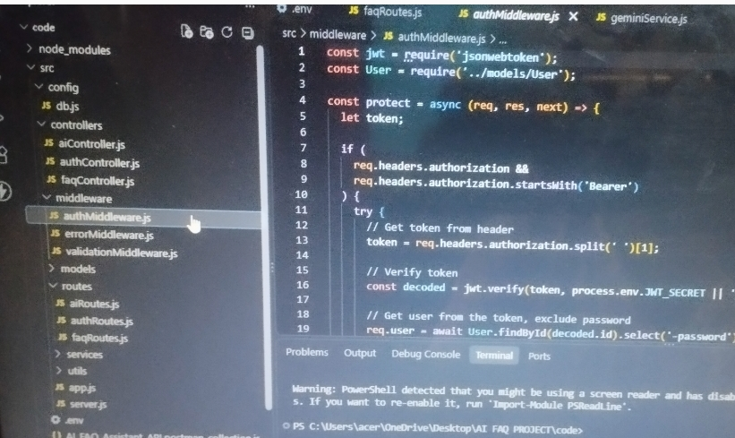
The authentication middleware intercepts incoming protected queries, extracts authorization header information, and validatestoken identity claims.
INSERT SCREENSHOT HERE authMiddleware.js
Figure 11: Authentication middleware source code

Centralized Error Handler Middleware
The centralized error handler providesconsistent API error processing and response handling.
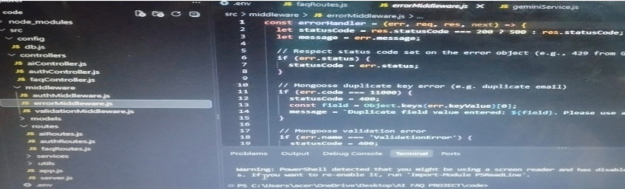
INSERT SCREENSHOT HERE errorMiddleware.js
Figure 12: Centralized error middleware source code

DATABASE CONFIGURATION

Mongoose Schema Definitions
Mongoose schemas define the structural rules for application documents and provide validation before persistence.

Identity Resource Document Schema –src/ models/ User.js
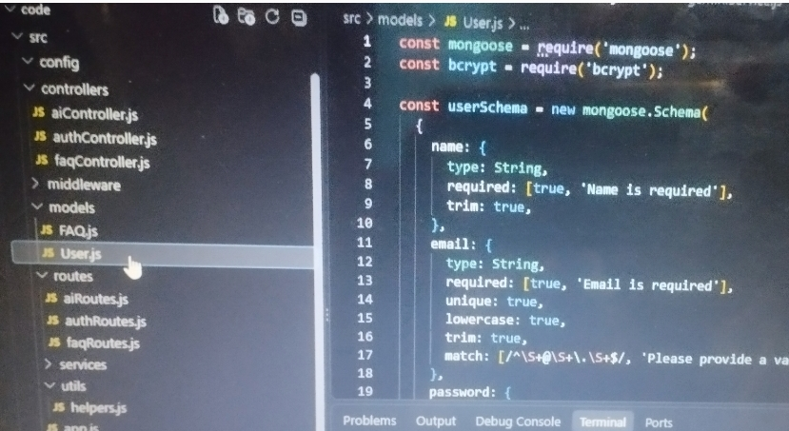
The User schema enforces profile field criteria and supports password hashing before user document persistence.
INSERT SCREENSHOT HERE User.js Model
Figure 13: User model schema

FAQ Resource Document Schema –src/ models/ FAQ.js
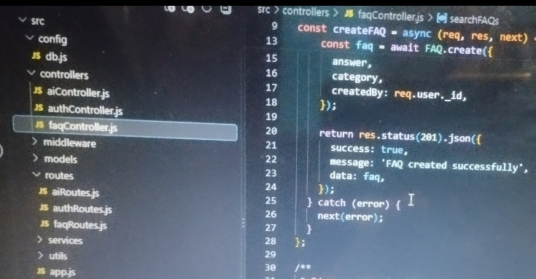
The FAQ model containsthe question, answer, category, creator reference, and timestamp fields.
INSERT SCREENSHOT HERE FAQ.js Model
Figure 14: FAQ model schema

API ROUTER INTERFACE ENDPOINTS
Module | File | Purpose
Public Authentication Operations | src/routes/authRoutes.js | Registration and login operations.
Protected FAQ Operations | src/routes/faqRoutes.js | FAQ resource operations protected by authentication.
AI Automation Operations | src/routes/aiRoutes.js | AI-assisted FAQ generation operations.
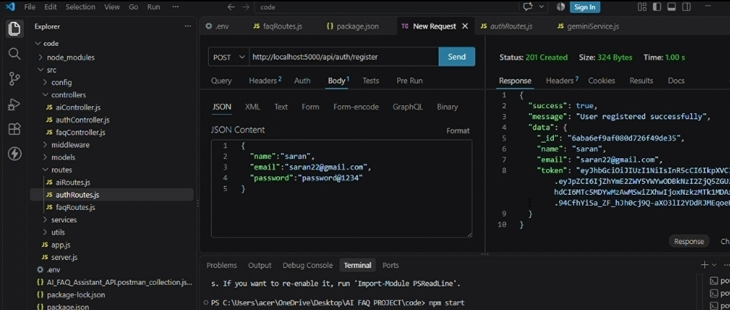
INSERT SCREENSHOT HERE API Route Files
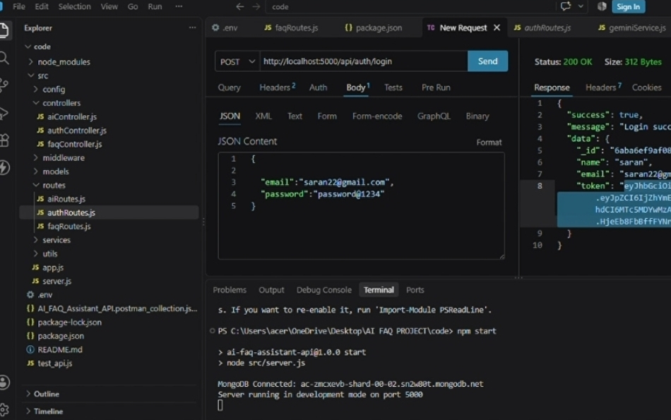
Figure 15: API route filesin VSCode

PROJECT EXECUTION
Install Postman or the ThunderClient VSCode extension for API verification.
Start the backend development server using the project'sconfigured development command.
INSERT SCREENSHOT HERE Running Backend Server
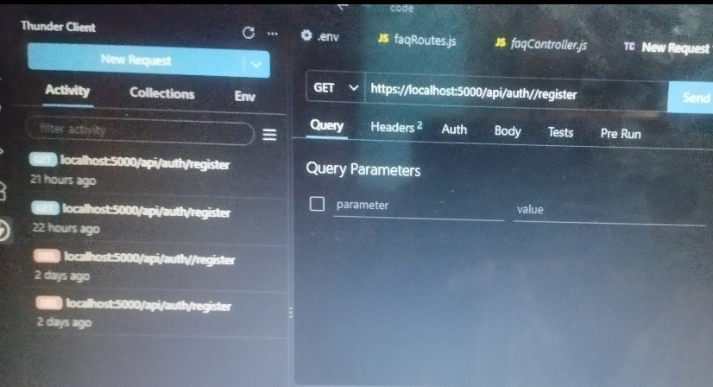
Figure 16: Backend server running successfully

API TESTINGSPECIFICATION

Identity Onboarding Path –Registration
Route: POST / api/ auth/ register Access: Public Request data:
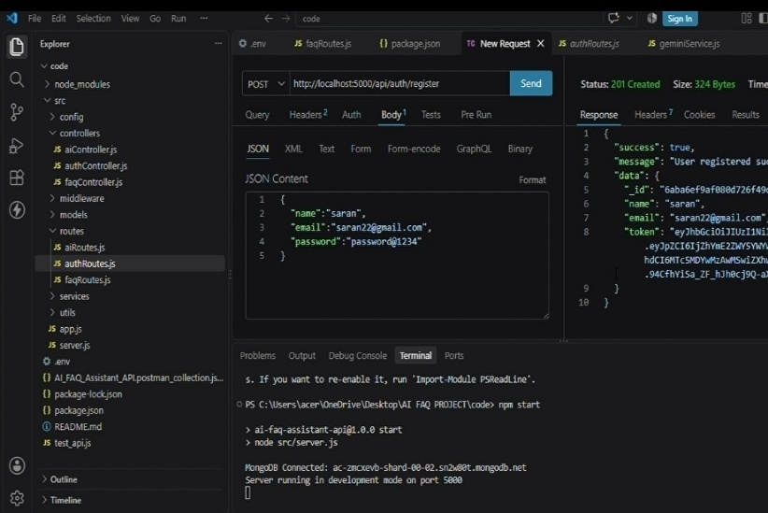
{"name":"Priya Sharma","email":"priya@writeflow.com","password":"securepassword123"}

INSERT SCREENSHOT HERE
Identity Onboarding Path – Registration – API Response
Figure: Screenshot of POST / api/ auth/ register request and response

Profile Login Verification
Route: POST /api/auth/login Access: Public Request data:
{"email":"priya@writeflow.com","password":"securepassword123"}
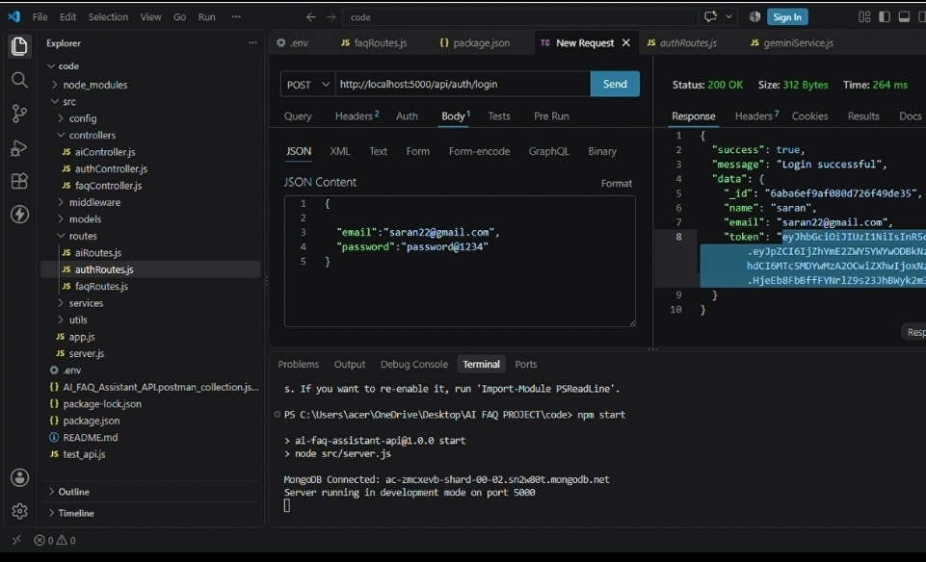
INSERT SCREENSHOT HERE Profile Login Verification – API Response
Figure: Screenshot of POST / api/ auth/ login request and response

Resource Entity Creation –FAQ
Route: POST /api/faqs
Access: Private (Bearer JWT Token) Request data:
{"question":"How do I configure custom category tags?","answer":"Navigate to settings panel, append keyword tags arrays, and save schema.","category":"Configuration"}

Resource Entity Creation – FAQ – API Response
Figure: Screenshot of POST / api/ faqsrequest and response

Keyword Resource Entity Fetching –Search
Route: GET / api/ faqs/ search?q=configure Access: Public Request data:
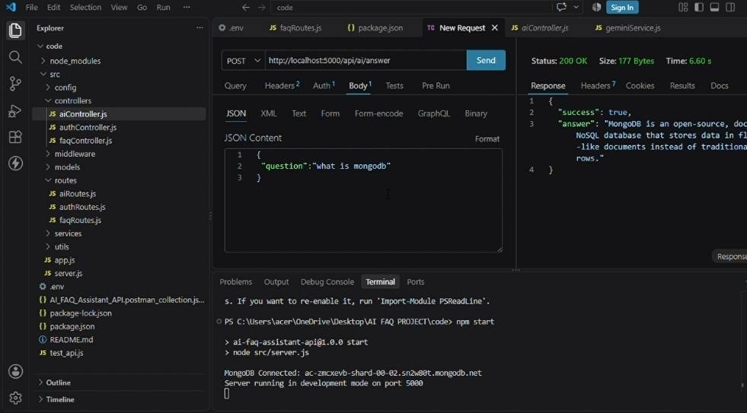
Query parameter: q=configure

INSERT SCREENSHOT HERE
Keyword Resource Entity Fetching – Search – API Response
Figure: Screenshot of GET / api/ faqs/ search?q=configure request and response

AI Intelligent Content Automation
Route: POST / api/ ai/ generate-faq Access: Private (Bearer JWT Token) Request data:
{"topic":"Mongoose schema indexing validation runtime workflow optimization"}

INSERT SCREENSHOT HERE
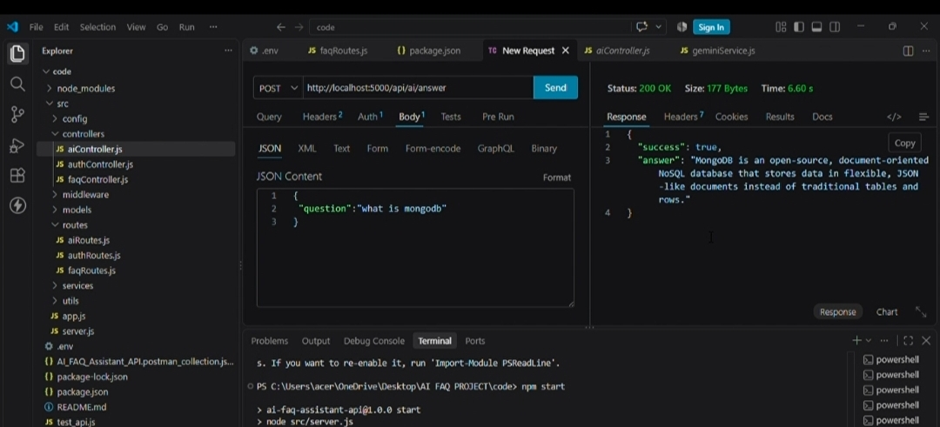
AI Intelligent Content Automation – API Response
Figure: Screenshot of POST / api/ ai/ generate-faq request and response

SCREENSHOTS/ PROJECT EVIDENCE
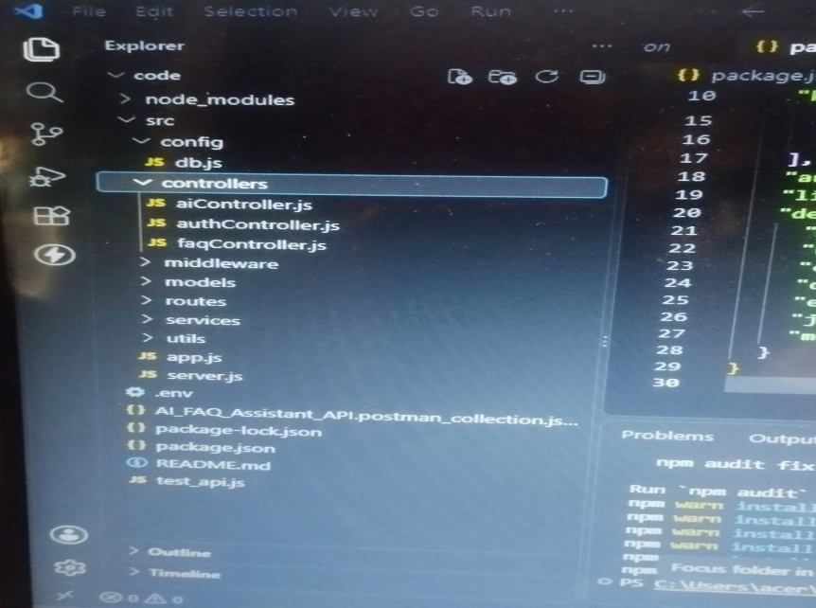
Insert your actual project screenshots in the following sequence. These placeholders are editable and can be replaced with imagesdirectly in Microsoft Word.
INSERT SCREENSHOT HERE Project folder structure
Figure 17: Project folder structure

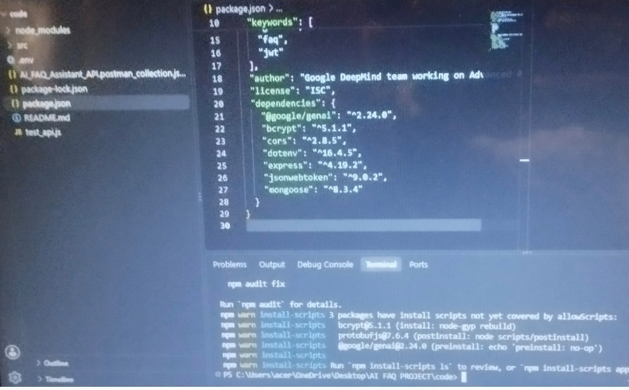
INSERT SCREENSHOT HERE
Node.js / npm installation or version check
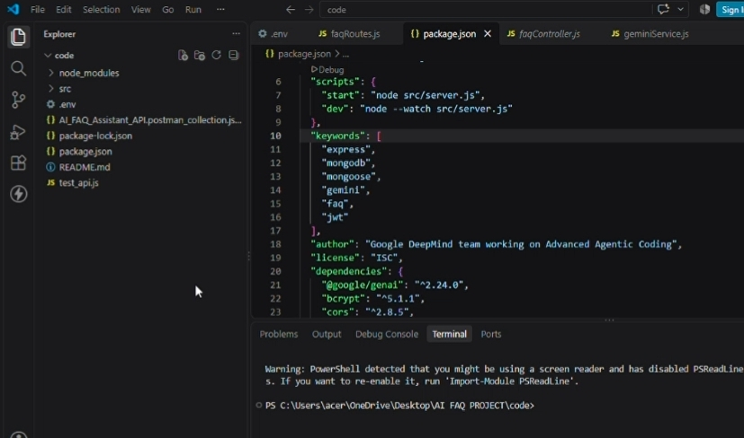
Figure 18: Node.js/ npm installation or version check

INSERT SCREENSHOT HERE VS Code project workspace
Figure 19: VSCode project workspace
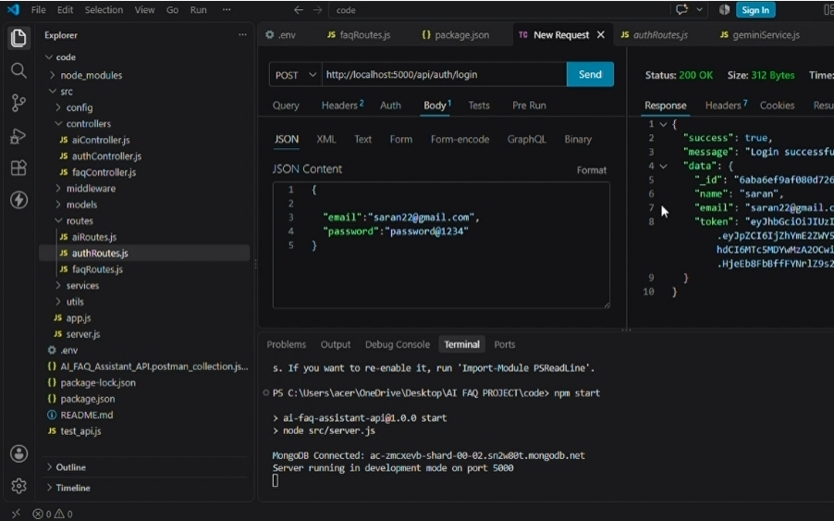
MongoDB database / collections
Figure 20: MongoDB database / collections
INSERT SCREENSHOT HERE User registration API
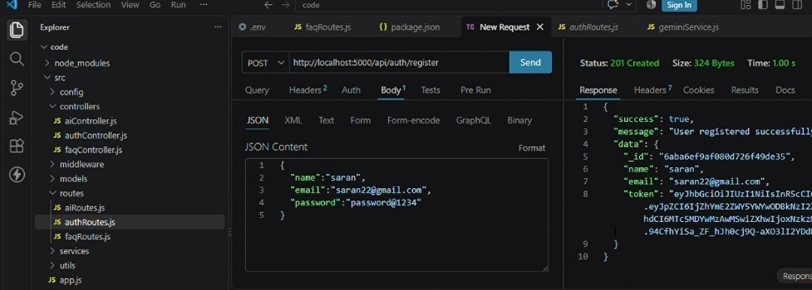
Figure 21: User registration API

INSERT SCREENSHOT HERE
User login API and JWT response
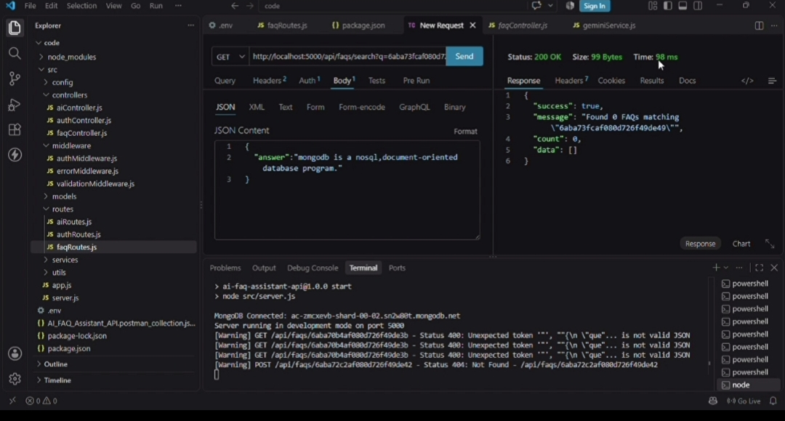
Figure 22: User login API and JWT response

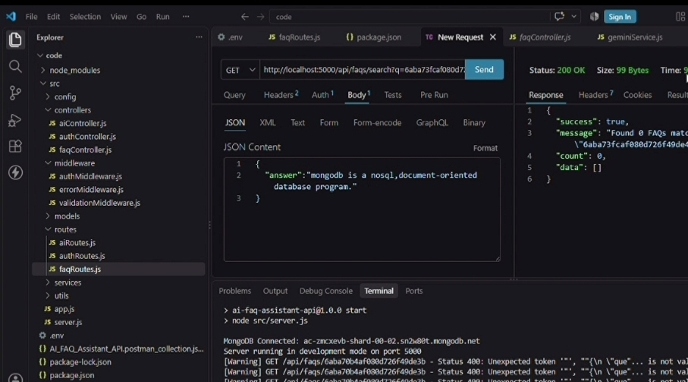
INSERT SCREENSHOT HERE Create FAQ API
Figure 23: Create FAQ API

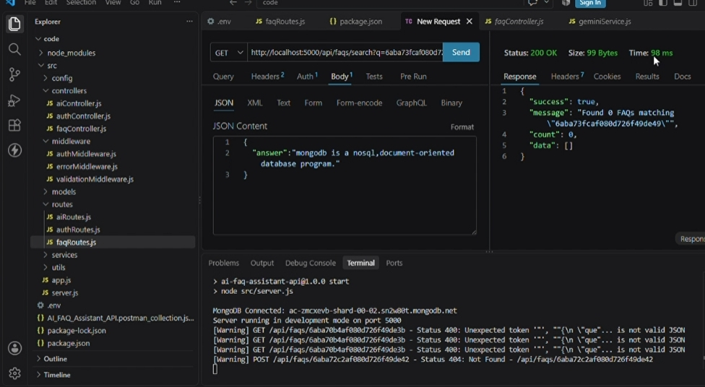
FAQ list / read API
Figure 24: FAQ list / read API
INSERT SCREENSHOT HERE
Update FAQ API
Figure 25: Update FAQAPI
INSERT SCREENSHOT HERE
Delete FAQ API
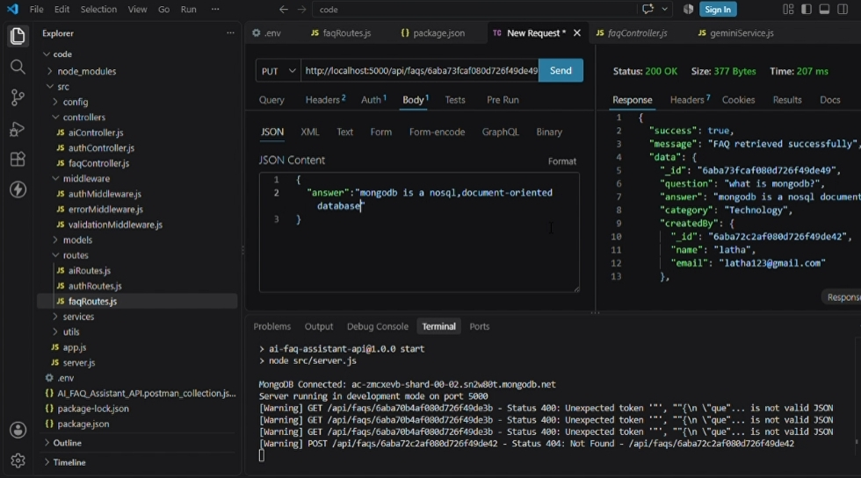
Figure 26: Delete FAQ API
INSERT SCREENSHOT HERE
FAQ search API
Figure 27: FAQsearch API
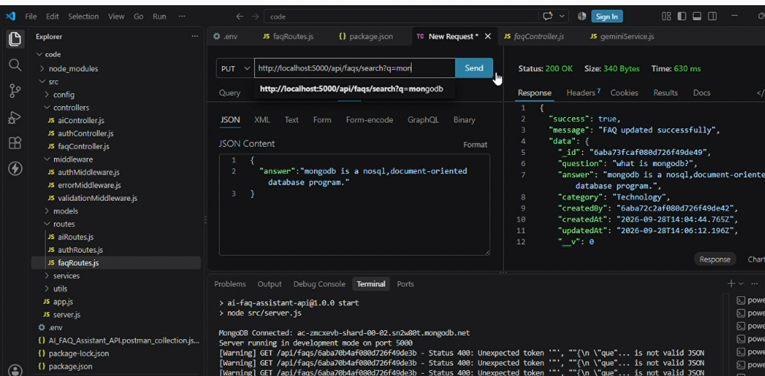
AI FAQ generation API
Figure 28: AI FAQ generation API
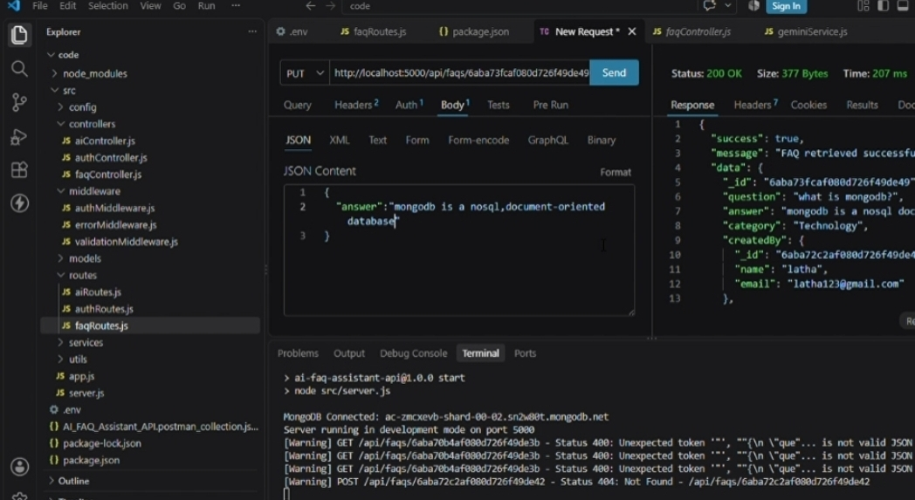
INSERT SCREENSHOT HERE Authentication middleware
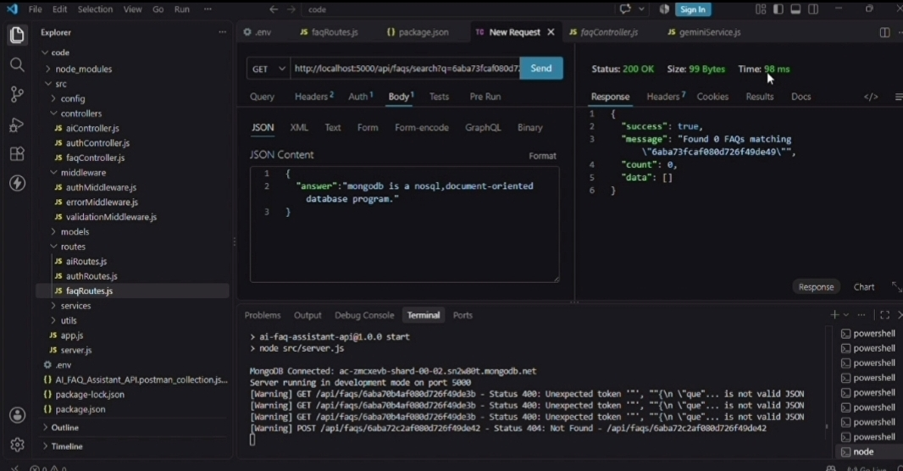
Figure 29: Authentication middleware

INSERT SCREENSHOT HERE
Final project execution / successful server output
Figure 30: Final project execution / successful server output

CONCLUSION
AnswerBot provides a centralized backend platform for FAQ management and customer support automation. The system combines Node.js and Express.js for RESTful API services, MongoDB and
Mongoose for document storage and validation, JWT and bcrypt for security, and Google
Gemini AI for automated FAQ generation. The modular architecture supports authentication, CRUD operations, category organization, semantic search, centralized error handling, and AIassisted content workflows.

FUTURE ENHANCEMENT
Extend AI-assisted FAQ generation workflows.
Improve semantic search and contextual query matching.
Add more administrative monitoring capabilities.
Expand category and content management features.
Provide additional API analyticsand reporting capabilities.

PROJECT REFERENCES/ LINKS
API Testing Video: Provided in the original reference document.
Demo Link: Provided in the original reference document.
CodeDrive: Code repository/ reference assupplied with the project.
Note: The original reference document contains the source links; they can be inserted here if required.

INSERT SCREENSHOT HERE Final Project Output / Demo
Final Figure: Complete project demonstration screenshot

